Mid Goulburn Groundwater Management Area

The Mid Goulburn Groundwater Management Area (GMA) extends from the foothills of the Great Dividing Range near Avenel to Wunghnu in the north and incorporates the towns of Nagambie, Tatura and Shepparton – refer to map overleaf.
Groundwater resources in the GMA are managed under a Local Management Plan, which was approved by Goulburn-Murray Water (GMW) in 2014 (the Plan).
Groundwater resources
Rainfall recorded in the GMA in 2023/24 was above average with 652.0 mm recorded at the Mangalore station 88109. Higher rainfalls in recent years has resulted in an increasing trend of groundwater levels in the Nagambie Zone, which has not occurred since the 1990s. Groundwater levels and rainfall charts are provided overleaf.
Seven licence holders have participated in an annual bore sampling program since 2016/17. Groundwater samples are collected at the same time each year (where practicable) and analysed for salinity. The data collected is used to monitor changes in groundwater salinity over time. Samples from five bores were collected and analysed in 2023/24.
A summary of the results are available on the GMW website from the address below.
www.gmwater.com.au/water-operations/water-information/ground-water/management/midgoulburngma
Groundwater licence volume and use
The total groundwater licence entitlement volume (licence volume) in the GMA is 12,464.9 megalitres per year (ML/yr) (Table 1). The permissible consumptive volume (PCV) for the GMA is 12,470 ML/yr. No licence volume can be issued in excess of the PCV.
Table 1. Licence volumes, use and limits for 2023/24
Management zone | Zone cap/ PCV (ML/yr) | Licence volume (ML/yr) | Recorded use (ML)
1070 Kialla | 8,000 | 6,540.9 | 1,233.8
1071 Nagambie | 8,000 | 5,924.0 | 954.2
Total | *12,470 | 12,464.9 | 2,188.0
*Note: The PCV is not equal to sum of zone caps.
Recorded use in the GMA in 2023/24 was 2,188.0 ML or 18 per cent of total licence volume (Figure 1).
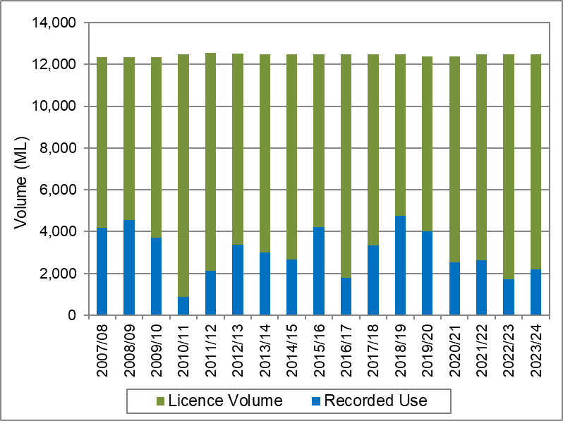
Figure 1. Annual recorded use as a proportion of licence volume in the Mid Goulburn GMA
Licence transfers
Under the Plan, licence holders in the GMA may transfer licence volume on a temporary or permanent basis, within or between management zones, provided zone limits are not exceeded.
No transfers occurred in the GMA during the 2023/24 water year.
Carryover
Under the Plan, licence holders may carryover up to 20 per cent of their unused licence volume for use in the previous year. The volume that has been carried over for use in 2024/25 is 2,459.28 ML.
Licence compliance
In 2023/24, there were no prosecutions or convictions relating to groundwater in the GMA.
GMW has a zero-tolerance approach to unauthorised take of non-urban water. Relevant actions, if required, are taken in accordance with GMW’s Risk-Based Compliance and Enforcement Framework. Please visit www.gmwater.com.au/compliance for further details.
Where can l get more information?
Visit www.gmwater.com.au to view the Plan, recent groundwater levels and other resources; or contact GMW on 1800 013 357.
To see the complete record of groundwater levels from the State Observation Bore Network please visit https://data.water.vic.gov.au/

